|  |  |
| --- | --- |
| 23SP042 | Exhibition of the Planning Proposal and draft Area Plan for the West Wallsend and Holmesville Heritage Conservation Area |

|  |  |
| --- | --- |
| Key focus area | 4. Diverse economy  5. Connected communities |
| Objective | 4.5 New development and growth complement our unique character and sense of place, now and into the future  5.3 We are proud of our city's heritage and cultures |
| File | F2012/02466/01/05 - D10859554 |
| Author | Senior Strategic Landuse Planner - Adam Kennedy |
| Responsible manager | Manager Integrated Planning - Wes Hain |

Executive Summary

This report proposes amendments to the *Lake Macquarie Local Environmental Plan 2014* *(LMLEP 2014)* and Lake Macquarie Development Control Plan 2014 (LMDCP 2014) relating to the heritage significance of West Wallsend and Holmesville.

The planning proposal (Attachment 1) seeks to increase the extent of the current Heritage Conservation Area and limit maximum building heights to predominantly 8.5m. The draft West Wallsend and Holmesville Heritage Conservation Area Plan (draft area plan) (Attachment 2) seeks to apply new planning controls that complement the proposed *LMLEP 2014* changes to protect the significance of the Heritage Conservation Area.

Both documents were prepared based on the recommendations of the West Wallsend and Holmesville Combined Working Report and Heritage Development Control Plan Study (the working report).

|  |
| --- |
| Recommendation  Council:   1. requests a Gateway Determination from the Department of Planning and Environment pursuant to the *Environmental Planning and Assessment Act 1979* *(EP&A Act 1979)* in relation to the planning proposal in Attachment 1, 2. requests the use of plan making delegations of the Minister for Planning and Public Spaces under section 3.36 of the *EP&A Act 1979* for the planning proposal, 3. undertakes consultation with State Government agencies and service authorities in accordance with the Gateway Determination, 4. prepares and exhibits the draft West Wallsend and Holmesville Heritage Conservation Area Plan (Attachment 2) which will replace the current West Wallsend and Holmesville Heritage Precinct Area Plan, 5. places the planning proposal and draft West Wallsend and Holmesville Heritage Conservation Area Plan on public exhibition for a period of at least 28 days, subject to the outcome of the Gateway Determination, 6. notifies stakeholders and affected landowners of the public exhibition, and 7. receives a further report detailing feedback received during exhibition and any proposed changes to the documents. |

Discussion

The heritage significance of West Wallsend was first recognised in the *Hunter Regional Environmental Plan 1989 (Heritage)* which identified the West Wallsend Heritage Conservation Area (HCA) as having local heritage significance, predominantly due to its mining heritage.

The Lake Macquarie City Council Heritage Study (1993) and more recently, the West Wallsend and Holmesville Background Heritage Study (2014) reinforced the heritage significance of West Wallsend, while also recommending the expansion of the HCA into parts of neighbouring Holmesville noting the “coherent expression of the early development of the village...and strong association with the pioneer Holmes family”.

West Wallsend HCA is one of three HCAs in the city. The other two are at Teralba and Catherine Hill Bay. Council’s Local Strategic Planning Statement (LSPS) identifies a need to review the West Wallsend HCA to facilitate growth while conserving the important heritage aspects of the area.

In 2020, Council engaged consultants to review the HCA and related development controls. The consultants prepared a working report which found the retention of the character of West Wallsend and Holmesville depends on the preservation of the original subdivision pattern, landscape setting and existing building stock with relatively homogeneous height, form and materials. Ongoing significant changes to these prevailing elements have the effect of changing the fundamental character of the area, diminishing its heritage significance.

The planning proposal seeks to amend the boundary of the HCA (refer to Figure 1) which has been informed by the working report recommendations and by the contributory gradings for individual properties graded as Contributory 1 and 2. The revised HCA boundary includes more heritage listed properties and properties graded as Contributory 1 and 2, along with capturing significant views and vistas that are part of the area’s setting, character and significance. The planning proposal also seeks to amend the Height of Buildings Map in the *LMLEP 2014* from 10m (up to three storeys) to 8.5m (up to two storeys) within the revised HCA boundary, except some properties on Carrington and Withers Streets in West Wallsend town centre which retain a 10m height of building control.

The draft area plan provides specific conservation objectives and development controls for the revised HCA. It provides clear directions for owners, applicants, designers and assessment staff to achieve development outcomes that are sympathetic to the heritage characteristics and values of the HCA. The current West Wallsend and Holmesville Precinct (Figure 2) will be removed and only the revised HCA (Figure 1) will apply with the supporting draft area plan controls. An explanation and details of contributory gradings for individual properties in the revised HCA are provided in Attachment 3.

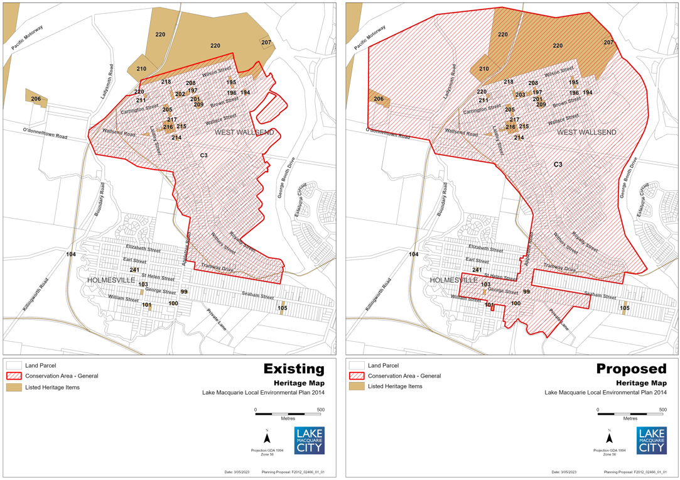

**Figure 1: The existing West Wallsend HCA boundary and local heritage items in the LMLEP 2014 (left) and proposed West Wallsend and Holmesville HCA boundary (right)**

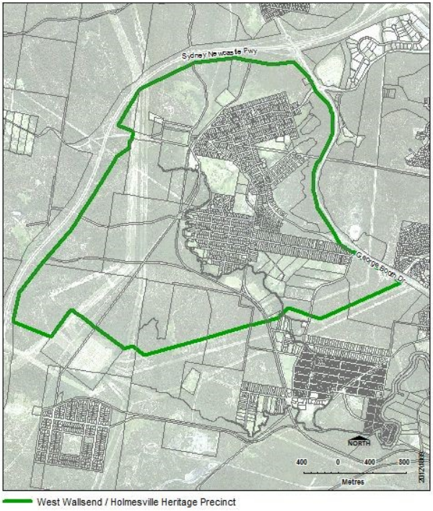

**Figure 2: Current West Wallsend and Holmesville Precinct Area Plan boundary in the LMDCP 2014**

The planning proposal and draft area plan are consistent with relevant regional and local planning strategies and policies. The proposed reduction in permissible building heights seeks to maintain the predominant low-scale streetscape provided by existing buildings, whilst still facilitating infill development.

Analysis shows one and two storey multi dwelling housing developments are likely to remain the most viable development outcomes in residential areas under the current and proposed planning controls. The permissible height of building will remain unchanged at 10m in most of the West Wallsend local centre. This is due to existing buildings on the Carrington and Withers Streets axis presenting at three storeys due to parapets and other unique design features. Reducing the building height from 10m to 8.5m in the rest of the HCA will support the retention of the important heritage character of the area.

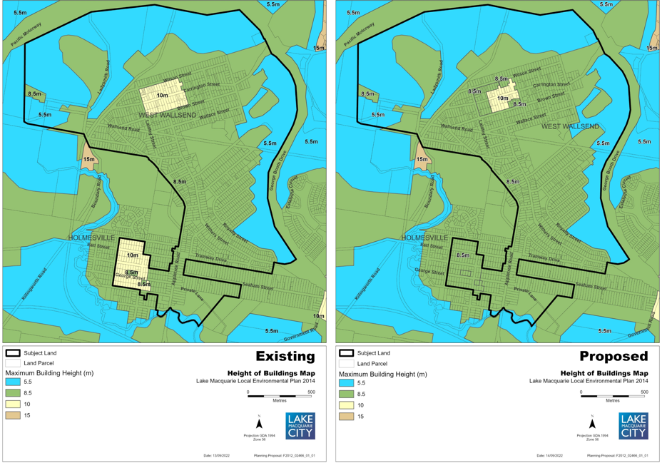

**Figure 3: Existing height of building (left) and proposed height of building (right)**

Balancing economic activity, development pressure and heritage conservation is challenging. Without reducing the building height to 8.5m, development pressure is likely to fragment the HCA, and risk degradation of important heritage qualities of West Wallsend and Holmesville over time. On balance, the recommended planning provisions will help deliver economic growth, facilitate appropriate development, conserve important heritage qualities and deliver social benefits to the townships.

Assessment of options

Proceeding with the planning proposal and draft area plan will provide certainty to proponents and landowners, and facilitate development outcomes that respect the significance and long-term heritage outcomes envisaged for the HCA. This is the recommended option.

Council can choose not to proceed with the planning proposal and draft area plan. This will maintain the existing planning controls and is not the recommended option. Maintaining the existing planning controls may result in a gradual decrease in the heritage value of the area due to their broad application and will result in continued confusion amongst proponents and landowners due to the difference between the HCA and heritage precinct in the current area plan.

Community engagement and internal consultation

**Internal consultation**

Consultation occurred with Council’s Development Assessment and Certification, Asset Management, Environmental Systems, Property and Business Development, Arts, Culture and Tourism, and Integrated Planning departments. Comments received during this internal consultation process were considered in the preparation of the planning proposal and draft area plan.

**Preliminary external consultation**

Key stakeholders of Transport for NSW and Heritage NSW were provided with a copy of the working report and draft area plan. No comments were received. The Hunter and Central Coast Development Corporation was also engaged due to its landholdings in the area and raised no objections to the proposal.

In its early review, the Department of Planning and Environment stated the planning proposal broadly aligns with the established strategic framework, being the Hunter Regional Plan 2041 and the Greater Newcastle Metropolitan Plan 2036.

Preliminary consultation was undertaken with landowners between 18 July to 15 August 2022, to inform them of proposed changes to planning controls that apply to their land, and to get feedback on the specific property contributory gradings that were prepared.

The working report, draft area plan and building contribution assessments were placed on Council’s Shape Lake Mac webpage. Feedback was obtained via online submissions and from two drop-in sessions held in West Wallsend and Holmesville. The project was also promoted via social media, mailouts and media release.

Preliminary consultation attracted 55 submissions. A summary of issues raised and staff responses is contained in Attachment 4.

**Proposed exhibition**

If Council endorses the recommendation, public exhibition for at least 28 days will provide an opportunity for the community, landowners and other key stakeholders to understand what is proposed and to comment on those proposed changes. The planning proposal, draft area plan and working report will be placed on exhibition. Exhibition is subject to the Department of Planning and Environment issuing Gateway Determination.

Following exhibition, community feedback will be considered and reported to Council with recommendations for any changes to the planning proposal and/or draft area plan.

Key considerations

|  |  |
| --- | --- |
| **Economic impacts** | There are no direct economic sustainability impacts associated with the exhibition of the planning proposal, draft area plan and working report. The planning proposal and draft area plan are designed to conserve the heritage significance of the HCA while facilitating appropriate future development growth within and around the West Wallsend and Holmesville local centres. |
| **Environment** | The draft planning proposal and draft area plan seek to protect the built and natural heritage values that give the area its distinct character, which promotes environmental sustainability. |
| **Community** | Exhibiting the planning proposal, draft area plan and working report will provide the community with an opportunity to comment on the future character and development controls aimed at preserving and maintaining the heritage values and distinct character of West Wallsend and Holmesville as pressure for urban infill development occurs. As such, the recommendation supports social sustainability. |
| **Civic leadership** | Exhibiting the planning proposal, draft area plan and working report will ensure ongoing collaboration with the community, which promotes sustainable governance. |
| **Financial** | The costs associated with public exhibition and community consultation processes will be funded from existing operational budgets. |
| **Infrastructure** | There are no direct infrastructure impacts associated with the exhibition of the planning proposal, draft area plan and working report. |
| **Risk and insurance** | There are minimal risk and insurance implications to Council in proceeding with the planning proposal and the draft area plan. Relevant legislative requirements and Council procedures for preparing the planning proposal and draft area plan have been followed. |

Legislative and policy considerations

*Environmental Planning and Assessment Act 1979*

*Environmental Planning and Assessment Regulation 2021*

Hunter Regional Plan 2041

Greater Newcastle Metropolitan Plan 2036

Lake Macquarie Community Strategic Plan 2022-2032

Lake Macquarie Local Strategic Planning Statement

*Lake Macquarie Local Environmental Plan 2014*

Lake Macquarie Development Control Plan 2014

Attachments

|  |  |  |  |
| --- | --- | --- | --- |
| 1. | Planning Proposal - West Wallsend and Holmesville Heritage Conservation Area | Under separate cover | D11075273 |
| 2. | Draft West Wallsend and Holmesville Heritage Conservation Area Plan | Under separate cover | D11075271 |
| 3. | Details of contributory gradings for individual properties and key changes for the West Wallsend Heritage Conservation Area |  | D10862546 |
| 4. | Summary of feedback from preliminary community engagement |  | D11079617 |